***Solution Section* 1.9 – Hyperbolic Functions**

***Exercise***

Rewrite the expression  in terms of exponentials and simplify the results as much as you can.

***Solution***









***Exercise***

Rewrite the expression  in terms of exponentials and simplify the results as much as you can.

***Solution***









***Exercise***

Prove the identities

1. 
2. 

***Solution***

1. 











1. 











***Exercise***

Find the derivative of 

***Solution***

 

***Exercise***

Find the derivative of 

***Solution***





***Exercise***

Find the derivative of 

***Solution***



***Exercise***

Find the derivative of 

***Solution***







***Exercise***

Find the derivative of 

***Solution***





***Exercise***

Find the derivative of 

***Solution***











***Exercise***

Find the derivative of 

***Solution***











***Exercise***

Find the derivative of 

***Solution***











***Exercise***

Find the derivative of 

***Solution***









***Exercise***

Find the derivative of 

***Solution***







***Exercise***

Find the derivative of 

***Solution***







***Exercise***

Find the derivative of 

***Solution***







***Exercise***

Find the derivative of 

***Solution***









***Exercise***

Find the derivative of 

***Solution***



***Exercise***

Find the derivative of 

***Solution***

 

***Exercise***

Find the derivative of 

***Solution***

 







***Exercise***

Find the derivative of 

***Solution***

 

***Exercise***

Find the derivative of 

***Solution***

 

***Exercise***

Find the derivative of 

***Solution***

 



***Exercise***

Find the derivative of 

***Solution***

 

***Exercise***

Find the derivative of 

***Solution***

 

***Exercise***

Find the derivative of 

***Solution***

 

***Exercise***

Find the derivative of 

***Solution***

 



***Exercise***

Find the derivative of 

***Solution***

 





***Exercise***

Find the derivative of 

***Solution***

 

***Exercise***

Find the derivative of 

***Solution***





***Exercise***

Find the derivative of 

***Solution***

 

***Exercise***

Find the derivative of 

***Solution***

 



***Exercise***

Find the derivative of 

***Solution***

 

***Exercise***

Find the derivative of 

***Solution***

 





***Exercise***

Find the derivative of 

***Solution***

 





***Exercise***

Find the derivative of 

***Solution***

 

***Exercise***

Find the derivative of 

***Solution***





***Exercise***

Find the derivative of 

***Solution***





***Exercise***

Find the derivative of 

***Solution***





 





***Exercise***

Find the derivative of 

***Solution***

 

***Exercise***

Find the derivative of 

***Solution***











***Exercise***

Find the derivative of 

***Solution***













***Exercise***

Verify the integration 

***Solution***

If 





 **√** Which verifies the formula

***Exercise***

Verify the integration 

***Solution***

If 





 **√** which verifies the formula

***Exercise***

Evaluate the integral: 

***Solution***





***Exercise***

Evaluate the integral: 

***Solution***

 



***Exercise***

Evaluate the integral: 

***Solution***

 









 



***Exercise***

Evaluate the integral: 

***Solution***

 











***Exercise***

Evaluate the integral: 

***Solution***

 



***Exercise***

Evaluate the integral: 

***Solution***

 

 

***Exercise***

Evaluate the integral: 

***Solution***

 

 

***Exercise***

Evaluate the integral 

***Solution***

 



***Exercise***

Evaluate the integral 

***Solution***

 



***Exercise***

Evaluate the integral 

***Solution***

 



***Exercise***

Evaluate the integral 

***Solution***

 

 

***Exercise***

Evaluate the integral 

***Solution***











***OR***













***Exercise***

Evaluate the integral 

***Solution***

 

***Exercise***

Evaluate the integral 

***Solution***

 

***Exercise***

Evaluate the integral 

***Solution***



***Exercise***

Evaluate the integral 

***Solution***





***Exercise***

Evaluate the integral 

***Solution***





***Exercise***

Evaluate the integral 

***Solution***





***Exercise***

Evaluate the integral 

***Solution***





***Exercise***

Evaluate the integral 

***Solution***

 



***Exercise***

Evaluate the integral 

***Solution***







***Exercise***

Evaluate the integral 

***Solution***





***Exercise***

Evaluate the integral 

***Solution***





***Exercise***

Evaluate the integral 

***Solution***





***Exercise***

Evaluate the integral 

***Solution***

 



***Exercise***

Evaluate the integral 

***Solution***

 

***Exercise***

Evaluate the integral 

***Solution***





***Exercise***

Evaluate the integral 

***Solution***

 



***Exercise***

Evaluate the integral 

***Solution***

 



***Exercise***

Evaluate the integral 

***Solution***

 



***Exercise***

Evaluate the integral 

***Solution***

 



***Exercise***

Evaluate the integral 

***Solution***





***Exercise***

Evaluate the integral 

***Solution***



















***Exercise***

Find the integral

***Solution***



 



 







***Exercise***

Evaluate the integral 

***Solution***















***Exercise***

Evaluate the integral 

***Solution***









***Exercise***

Evaluate the integral 

***Solution***

 

 







***Exercise***

Evaluate the integral 

***Solution***

 





***Exercise***

Evaluate the integral 

***Solution***

 







***Exercise***

Evaluate the integral 

***Solution***

















***Exercise***

Evaluate the integral 

***Solution***















***Exercise***

Evaluate the integral 

***Solution***

 







***Exercise***

Evaluate the integral 

***Solution***

 





***Exercise***

Evaluate the integral 

***Solution***



























***Exercise***

Evaluate the integral: 

***Solution***



 













***Exercise***

Evaluate the integral: 

***Solution***

 









***Exercise***

Evaluate the integral: 

***Solution***











***Exercise***

Evaluate the integral: 

***Solution***















***Exercise\****

Evaluate the integral: 

***Solution***





















***Exercise***

Evaluate the integral: 

***Solution***

 







***Exercise***

Evaluate the integral: 

***Solution***

 

 





 



***Exercise***

Evaluate the integral: 

***Solution***

 







***Exercise***

Evaluate the integral: 

***Solution***

 

 







***Exercise***

Evaluate the integral: 

***Solution***

 





***Exercise***

Evaluate the integral: 

***Solution***

 





***Exercise***

Evaluate the integral: 

***Solution***

 









***Exercise***

Evaluate the integral: 

***Solution***

 







***Exercise***

Evaluate the integral: 

***Solution***











***Exercise***

Derive the formula  for all real *x*. Explain in your derivation why the plus sign is used with the square root instead of the minus sign

***Solution***













Since  (***impossible***) 



***Exercise***

Find the linear approximation to  at  and then use it to approximate the value of .

***Solution***



















Linearization:











***Exercise***

Evaluate the limit: 

***Solution***































***Exercise***

Evaluate the limit: 

***Solution***



 





***Exercise***

Evaluate the limit: 

***Solution***

 





***Exercise***

Evaluate the limit: 

***Solution***

 





***Exercise***

Evaluate the limit: 

***Solution***









***Exercise***

Evaluate the limit: 

***Solution***









***Exercise***

Evaluate the limit: 

***Solution***

 







***Exercise***

Evaluate the limit: 

***Solution***

 







***Exercise***

Evaluate the limit: 

***Solution***

 







***Exercise***

Evaluate the limit: 

***Solution***

 





***Exercise***

Evaluate the limit: 

***Solution***

 





***Exercise***

Evaluate the limit: 

***Solution***

 

 L’Hôpital Rule





***Exercise***

Evaluate the limit: 

***Solution***

 





***Exercise***

Evaluate the limit: 

***Solution***



 



***Exercise***

Show that 

***Solution***













 ***√***

***Exercise***

Show that 

***Solution***

 





 



 ***√***

***Exercise***

Find the area of the region bounded by , and the unit circle.

***Solution***

The area of a quarter circle 

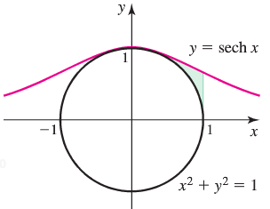

















***Exercise***

Find the area of the region bounded by the curves  and 

***Solution***

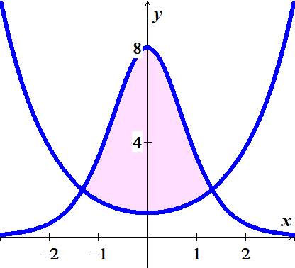





 



























***Exercise***

Find the area of the region bounded by the given: 

***Solution***

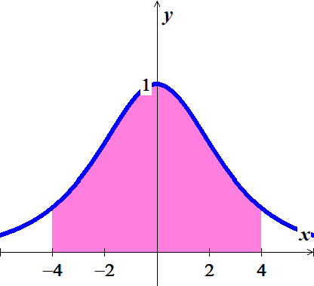















***Exercise***

Find the area of the region bounded by the given: 

***Solution***



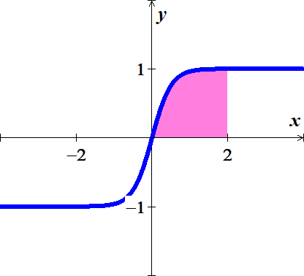 











***Exercise***

Find the area of the region bounded by the given: 

***Solution***













***Exercise***

Find the area of the region bounded by the given: 

***Solution***

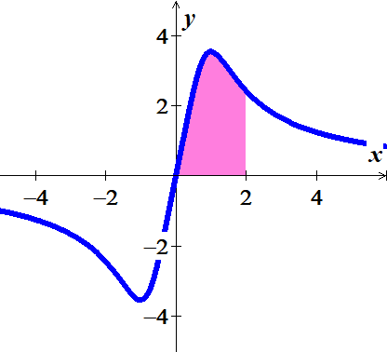









***Exercise***

Find the area of the region bounded by the given: 

***Solution***

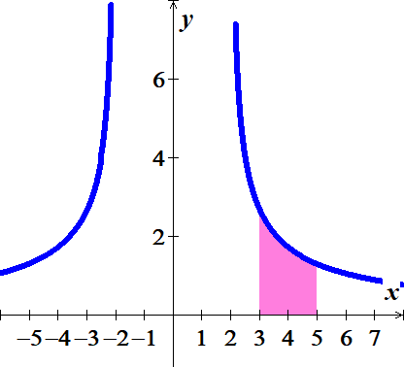







***Exercise***

Find the length of the curve 

***Solution***







 











***Exercise***

Find the length of the curve 

***Solution***







 











***Exercise***

A region in the first quadrant is bounded above the curve *y* = cosh*x*, below by the curve *y* = sinh*x*, and on the left and right by the *y*-axis and the line *x* = 2, respectively. Find the volume of the solid generated by revolving the region about the *x*-axis.

***Solution***









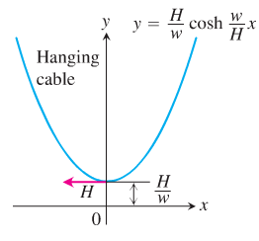***Exercise***

Imagine a cable, like a telephone line or TV cable, strung from one support to another and hanging freely. The cable’s weight per unit length is a constant *w* and the horizontal tension at its lowest point is a vector of length *H*. If we choose a coordinate system for the plane of the cable in which the *x*-axis is horizontal, the force of gravity is straight down, the positive *y*-axis points straight up, and the lowest point of the cable lies at the point  on the *y*-axis, then it can be shown that the cable lies along the graph of the hyperbolic cosine



Such a curve is sometimes called a ***chain curve*** or a ***catenary***, the latter deriving from the Latin *catena*, meaning “*chain*”.

1. Let  denote an arbitrary point on the cable. The next accompanying displays the tension *H* at the lowest point *A*. Show that the cable’s slope at *P* is



1. Using the result in part (*a*) and the fact that the horizontal tension at *P* must equal *H* (the cable is not moving), show that . Hence, the magnitude of the tension at  is exactly equal to the weight of *y* units of cable.
2. 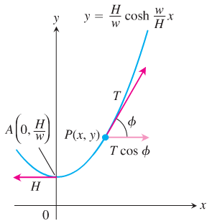The length of arc *AP* is , where . Show that the coordinates of *P* may be expressed in terms of *s* as 

***Solution***

1. 





1. The tension at *P* is given by .







 

 



1. 





 









***Exercise***

The portion of the curve  that lies above the *x-*axis forms a catenary arch. Find the average height of the arch above the *x-*axis.

***Solution***

By symmetry;













***Exercise***

A power line is attached at the same height to two utility poles that are separated by a distance of 100 *ft*; the power line follows the curve . Use the following steps to find the value of *a* that produces a sag of 10 *ft*. midway between the poles. Use the coordinate system that places the poles at 

1. Show that *a* satisfies the equation 
2. Let , confirm that the equation in part (*a*) reduces to , and solve for t using a graphing utility. (2 decimal places)
3. Use the answer in part (*b*) to find a and then compute the length of the power line.

***Solution***

1. Let  (*sag*).









1. If 

 



1. If 

The length of the power line is:









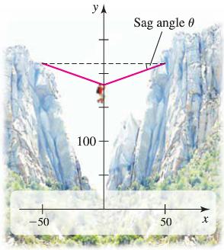***Exercise***

Imagine a climber clipping onto the rope and pulling hinself to the rope’s midpoint. Because the rope is supporting the weight of the climber, it no longer takes the shape of the catenary . Instead, the rope (nearly) forms two sides of an isosceles triangle. Compute the sag angle illustrated in the figure, assuming that the rope does not stretch when weighted. Assume the length of the rope is 101 *feet*.

***Solution***



***Exercise***

Find the volume interior to the inverted catenary kiln (an oven used to fire pottery).

***Solution***



Therfore; the area is between  and .

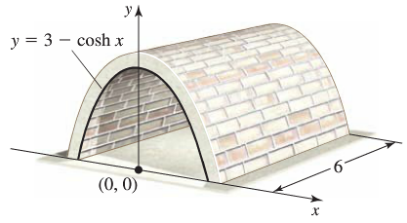









***Exercise***

A person is holding a rope that is tied to a boat. As the person walks along the dock, the boat travels along a ***tractrix***, given by the equation



Where *a* is the length of the rope.

If , find the distance the person must walk to bring the boat 5 *feet* from the dock.

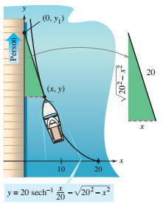***Solution***

Total distance of the person:

















